**Project Design Phase-II**

**Data Flow Diagram & User Stories**

|  |  |
| --- | --- |
| Date | 20-06-2025 |
| Team ID | LTVIP2025TMID49405 |
| Project Name | Measuring the Pulse of Prosperity: An Index of Economic Freedom Analysis |
| Maximum Marks | 4 Marks |

**Data Flow Diagrams:**

A Data Flow Diagram (DFD) is a traditional visual representation of the information flows within a system. A neat and clear DFD can depict the right amount of the system requirement graphically. It shows how data enters and leaves the system, what changes the information, and where data is stored.



**Example:** [**(Simplified)**](https://developer.ibm.com/patterns/visualize-unstructured-text/)

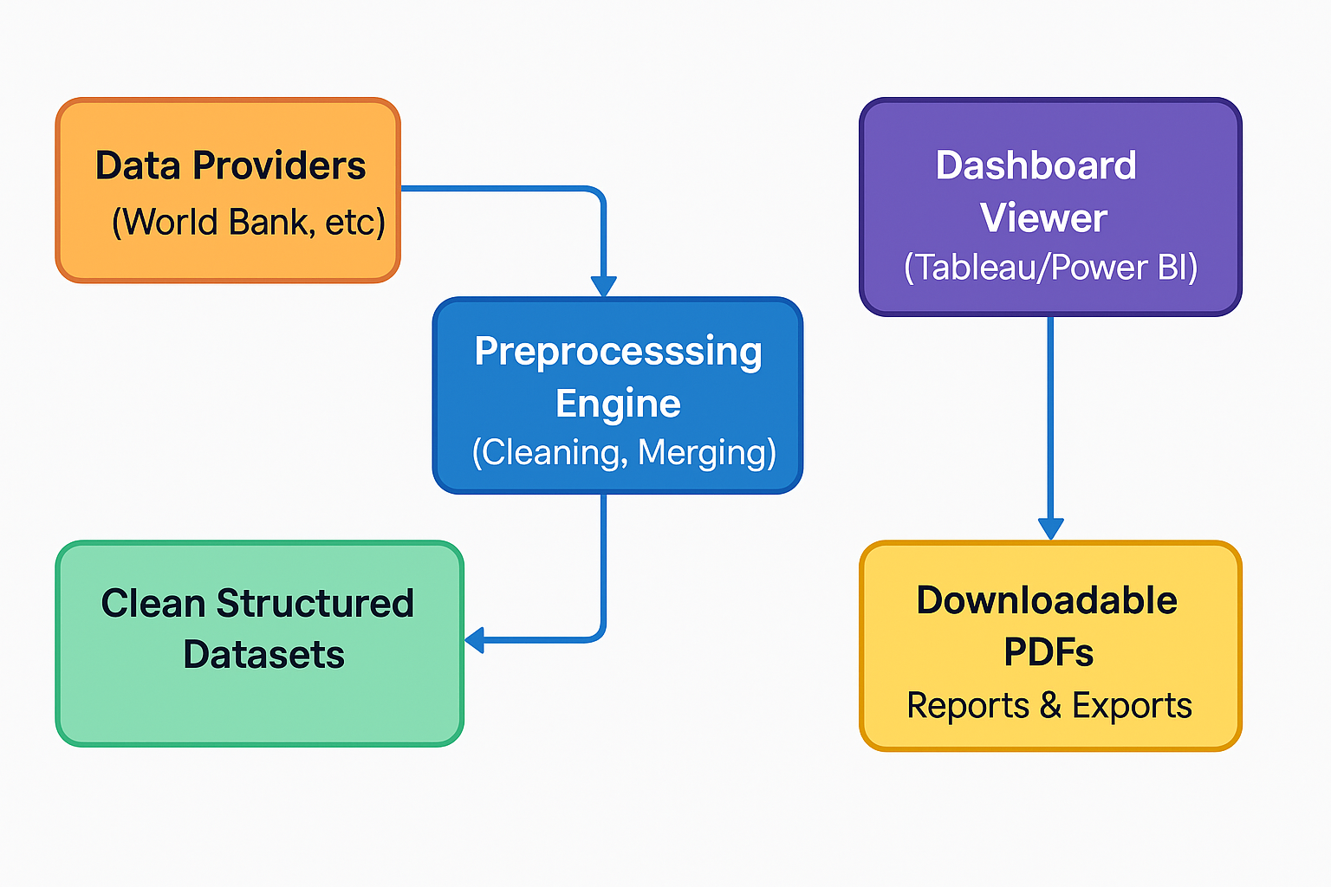

**User Stories**

Use the below template to list all the user stories for the product.

|  |  |  |  |  |  |
| --- | --- | --- | --- | --- | --- |
| **User Type** | **Functional Requirement (Epic)** | **User Story Number** | **User Story / Task** | **Acceptance Criteria** | **Priority / Release** |
| Research Analyst | Data Upload | USN-1 | Upload Economic Freedom Index and GDP datasets | Files upload successfully and appear in dataset list | High / Sprint-1 |
| Research Analyst | Data Preprocessing | USN-2 | Clean and merge uploaded datasets | Cleaned dataset is previewable with no missing values | High / Sprint-1 |
| Research Analyst | Visualization Setup | USN-3 | Visualize country-wise freedom scores | Charts render for each selected region | High / Sprint-2 |
| Research Analyst | Comparative Analysis | USN-4 | Correlate freedom index with GDP/HDI | Correlation graphs display accurately | Medium / Sprint-2 |
| Research Analyst | Filtering & Interaction | USN-5 | Filter data by year or region | Filters work and update views immediately | High / Sprint-2 |
| Research Analyst | Export | USN-6 | Export dashboard views to PDF | Download includes current view and filter | Medium / Sprint-3 |